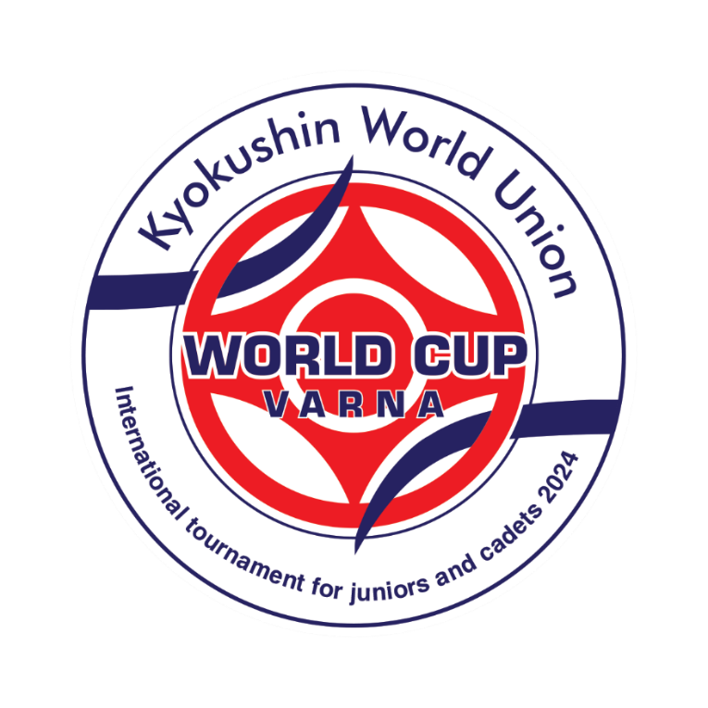
- Organizers: KWU International Professional League and BKKF

- Date and venue: 02.07.2024 /Thuesday/, Kamchia, 34 km to the South of Varna.

- Conditions of access to participation:

Participants must take part in all activities of the International Summer Camp in Kamchia.
Juniors (14-15 years old) and juniors (16-17 years old) - Representatives of national federations selected at national championships with the invitation of all interested kyokushin groups in a given country, aged 14 to 17, with stylistic qualifications of at least 6 kyu and up to 1 fighter in a weight category from organization per country, are allowed to participate in the competition.
Cadets (18-21 years old) - Representatives of national federations selected at national championships with the invitation of all interested kyokushin groups in a given country, aged 18 to 21, with stylistic qualifications of at least 6 kyu and up to 1 fighter in a weight category from an organization per country, are allowed to participate in the competition.
The organizers keep the right to change the categories or limit the number of competitors, according to the actual number of participants.

Timeline of events:

Date | Time | Event | Participants
30.06.2024 | All day | Arrival of participants | Judges  Leaders,  team representatives, fighters, coaches,  medics
01.07.2024 | 10:00-12:00  14:00-16:00 | Judging seminar | Judges
01.07.2024 | 09.00 – 19.00 | Credentials Committee World Cup Varna | Team representatives, fighters
02.07.2024 | 10:00 | Ceremonial opening | All
02.07.2024 | 10:15 | Beginning | All
02.07.2024 |  | Awarding ceremony | All

Registration for World Cup Varna: https://app.kumitetechnology.com/en/auth/sign-in/

Deadline for registration: June 10th, 2024
Contact phone numbers:
+359 88 4996666 Viliana Bozhilova
+359 88 9907857 Aleksandra Marinova

The approved list of participants will be published on June 14th, 2024

Financial conditions:

The organizers cover the costs:
Participants of the WORLD CUP VARNA, 1 coach per organization, 1 national representative per organization – accommodation, food, transfer (30.06.2024 airport Varna – Kamchia, 07.07.2024 Kamchia – airport Varna)

General rules:
The competitions will be held by the rules of KWU, which are posted on the official website: www.kwunion.com

Judges:
The national representatives who will participate in the XVIII International summer camp will be included in the judging brigades of the competitions. Attendance at referee seminars is mandatory.
The uniform of the judges of the competition: dogi and belt.

Chief referee of the tournament – Shihan Francisco Filho, 7th dan
Co-chief referee of the tournament – Sensei Ivan Ivanov, 4th dan

Awards:

Terms of summarizing:
Sports competitions in kumite are held on a system with elimination after one defeat. Weight categories 14-15 years and 16-17 years have two third places (in case of insufficient participants, the organizers have the right to combine weight categories).

Weight categories 18-21 will be from 1 to 4 places (in case of insufficient participants, the organizers have the right to combine weight categories).

Awarding of champions and prizewinners:
Champions and prize-winners (1st-3rd places) in the age category 14-15 years and 16-17 years are awarded medals and diplomas as well as cups of corresponding grade.

Champions and prize-winners (1st-4th places) in the age category 18-21 years are awarded medals, diplomas, cups of corresponding grade, and cash prizes:
Men Women
1 place 5 000€ 1 place 3 500€
2 place 3 500€ 2 place 2 500€
3 place 2 000€ 3 place 1 500€
4 place 1 000€ 4 place 1 000€

Anti-doping control
Winners from 1st to 3rd place will undergo a doping test in accordance with the rules of the World Anti-Doping Agency (WADA).

Weight categories and composition of teams:
Composition of fighters and amount composition of a team:
- official team coach from the organization.
- one National Representative from the organization.
- fighter from the organization.

.

№ | Age category | Weight category
1 | boys (14-15 full years, kumite) | 50, 60, 70, 70+
2 | girls (14-15 full years, kumite) | 45, 55, 60, 60+
3 | boys (16-17 full years, kumite) | 55, 65, 75, 75+
4 | girls (16-17 full years, kumite) | 55, 65, 65+
5 | cadets men (18-21 full years, kumite) | 75, 85, 85+
6 | cadets women (18-21 full years, kumite) | 60, 60+
*The age of the fighters is determined on the day of passing the credentials commission that is July 1, 2024.

Obligations of fighters:
During the credentials commission, the leader of the team gives the original application (hard printed copy), and each fighter must have the following documents with him/her:
- Passport or birth certificate;
- allowance of sports medic to participate in competitions (in English);
- written application of a fighter – attachment №2;
- written permission to participate from both parents - attachment №3;
- HIV antibodies test certificate (only for 18-21 years fighters - in English);
- HBV antibodies test certificate (only for 18-21 years fighters - in English);
- HCV antibodies test certificate (only for 18-21 years fighters - in English);
- agreement of insurance from accident, valid at the time of competitions and list with names of insurance people with stamp (original, in English);

Protection:
Each fighter, allowed to participate in competitions, must have:
- white karategi and a belt, representing the fighter’s qualification;
- individual groin shell: for boys– mandatory, for girls– voluntary;
- protectors for shin and insteps – mandatory for girls;
- chest protector of a standard type - for girls and women;
- gum shield (oral cavity protector), white color – voluntary. If there are brackets on teeth, a gum shield is mandatory.

All protection items must have a mark of Organizers.
All participants will have a possibility to purchase protection items before the credentials committee.
ATTENTION! All protection items must be individual; each fighter must have his own according to the rules.

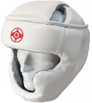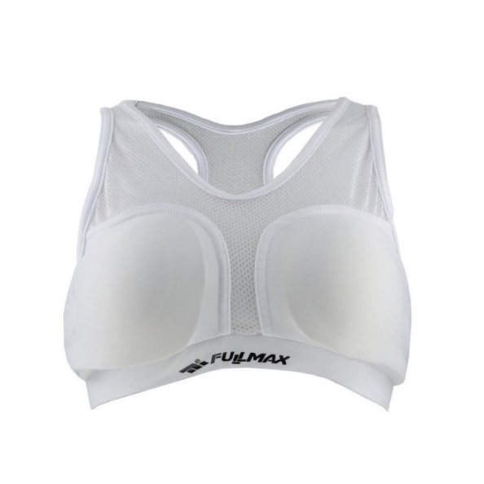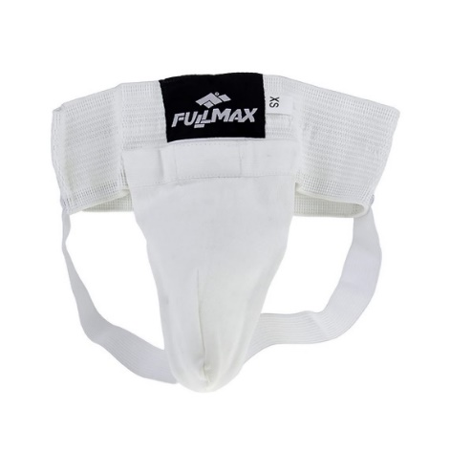
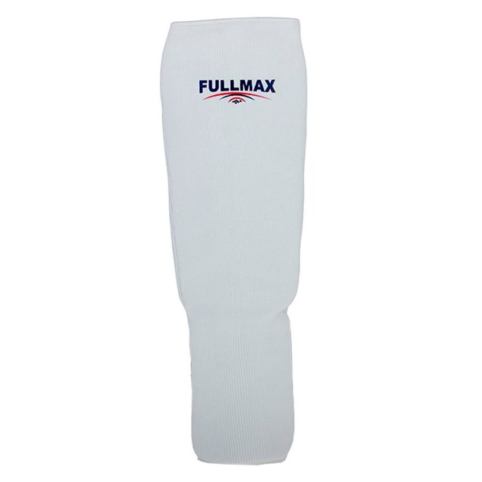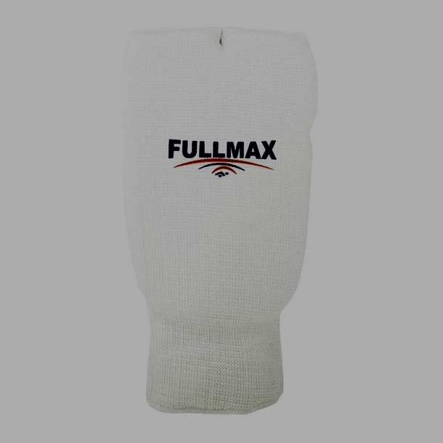

Duration of fights:

Age category “boys/ girls” (14-15 years)
Preliminary fights: 2 minutes + 2 minutes
Semi-final and final fights: 2 minutes + 2 minutes + weight check (weight difference 3 kg and more) + 1 minute

Age category “boys/ girls” (16-17 years)
Preliminary fights: 2 minutes + 2 minutes
Semi-final and final fights: 2 minutes + 2 minutes + weight check (weight difference 3 kg and more) + 2 minutes

Age category cadets (18-21 years)
Preliminary fights: 2 minutes + 2 minutes – decision;
Semi-final and final fights: 3 minutes + 2 minutes + weight check (weight difference 3 kg and more) + 2 minutes

Attachment № 1
APPLICATION FORM

I ……………………………………………………………………………………..................................
(Full name, phone number, ID/passport number, address)
as a coach of the following kyokushin karate athletes:
Full name ..................
Full name ..................
Full name ..................
I request that you let these athletes participate in the weight category................ in World Cup Varna, which will be held on July 02, 2024, in Kamchia, Bulgaria.
I certify that these athletes are in good physical shape and that their health allows them to participate in the competition.

I and the athletes I apply hereby waive and discharge the organizers of the competition, judges, coaches, instructors, other officials, as well as NPO “Bulgarian Karate Kyokushin Federation” and KWU International Professional League from any and all claims arising out of injuries and their adverse consequences, sustained during or after participation in the World Cup Varna.

_________________________________________________ __________________
Full name in own handwriting Signature

Attachment № 2
APPLICATION FORM

I __________________________________________________________________________________
(Full name, phone number, passport ID, address)

I hereby request permission to participate in the weight category ________ in the World Cup Varna, which will be held on 02.07.2024 in Kamchia, Bulgaria.
I certify that I am well prepared and in good physical shape, and my state of health allows me to participate in the competition.
I certify that I am familiar with the competition Rules in Kyokushin. I fully acknowledge that Kyokushin is a full-contact combat sport, and I understand the risk of injuries and any other adverse consequences.
I hereby waive and discharge the organizers of the competition, judges, coaches, instructors, and other officials, as well as NPO “Bulgarian Karate Kyokushin Federation” and KWU International Professional League from any and all claims arising out of injuries and their adverse consequences, sustained during or after participation in the World Cup Varna.
I declare that I do not use any drugs prohibited by the anti-doping rules, and I give my consent, if necessary, to pass the doping test and undergo a medical examination.

_________________________________________________ __________________
Full name in own handwriting Signature

Attachment № 3

DECLARATION

I…………………………………………………………………………………………………………………………
(full names, telephone number, ID/PIN number, and exact address on ID card),
as a legal representative of

I………………………………………………………………………………………………………………………….
(full names, telephone number, ID/PIN number, and exact address on ID card),
as a legal representative of

…………………………………………………………………………………………………
(full names, PIN/ID telephone number)

I DECLARE THAT,

I would like my child to be allowed to participate in category................ in …………… World Cup Varna for juniors (14-15), juniors (16-17), and cadets (18-21) (kumite), which will be held July 2, 2024, in Bulgaria, Varna, Kamchia.
I give clear approval that my child will participate in this tournament in order to strengthen of health and increase their physical and sports culture.
In addition, I confirm that we are familiar with safety rules during the competitions, that my child will respect them, and that he/ she has followed instructions.
I declare that my child is healthy, well-prepared, and free of obstacles to his/her participation in the competition.
I am aware that in case of injuries or other adverse circumstances and consequences during and after the World Cup Varna, which will be held July 2, 2024, in Bulgaria, Varna, Kamchia, I will bear the cost of my child’s treatment and recovery without having claims against the competition organizers, judges, coaches, trainers, and other officials and the NPO “Bulgarian Karate Kyokushin Federation” and KWU International Professional League.
This declaration I issue with a clear conscience and without foreign interference. I fully understand that Kyokushin Karate is a contact sport with direct fighting, and it is absolutely possible for my child to receive injuries and adverse consequences for participating in the competition. I confirm that my child does not use prohibited drugs, and I give my agreement, if necessary, that a doping sample is to be taken and a medical check is to be done.

1. DECLARANT:
2. DECLARANT:

